Final Project
Module Name:
Module ID:
Student Name:
Student ID:

Table of Contents
Introduction 3
Aim and Objectives 3
Estimated Process / Approach Plan 4
Business Model Presentation 5
Marketing Department Structure & Architecture 6
CRM System Design 9
Marketing Strategies / Campaign Ideas 10
KPIs and Data Points 11
Data & Analytics Framework 13
Optimization Model (Excel Solver LP) 13
Conclusion 14
References 16

Introduction
The e-commerce industry has revolutionized the way retail business is conducted across borders to include aspects of technology, data analytics and personalized marketing to enhance consumer experiences. Amazon UK is one of the key participants, who control the online retail market in Britain and offer a wide range of products, which includes not only electronics, fashion and groceries but also cloud and entertainment services. A strong customer behaviour perception coupled with a willingness to make data driven decision making is a key contributor to its success. The current hypercompetitive digital world has made efficient marketing management and advanced analytics relevant towards maintaining growth and customer retention. Amazon UK applies a complex marketing eco system that combines digital media, customer relationship management, and predictive analytics in providing highly personalised experiences. With these systems, Amazon can communicate with customers in a variety of touchpoints, including the web, mobile application, Alexa and email, in addition to optimising real-time communication and conversions.
This project intends to develop a holistic marketing department structure and CRM architecture that complies with the operational and strategic objectives of Amazon UK. The suggested model emphasises the combination of marketing, analytics, and operations through the use of such instruments as Key Performance Indicators and quantifiable data points the research will demonstrate the potential of the structured marketing analytics to reinforce the brand positioning, enhance customer retention, and make marketing more efficient. Lastly, this report provides an insight on how a data orientation marketing model can enable Amazon UK to sustain a competitive edge and proceed in establishing best practices in customer experience and operational efficiency.

Aim and Objectives
Aim
This project is primarily aimed to design a data driven marketing department/CRM architecture at Amazon UK that enhances customer engagement, profitability and retention.
Objectives
- To build a unified marketing framework that would be in line with customer centric strategy of Amazon.
- To establish a CRM model with easy information exchange and customer experiences.
- To leverage the use of analytics and optimisation models to increase the effectiveness of campaigns and allocation of resources.
- To have measurable KPIs to measure performance, marketing ROI and customer lifetime value, evidence based decision making that is supported in the marketing ecosystem.

Estimated Process / Approach Plan
The project uses a data based and phased approach to designing the marketing department and CRM architecture at Amazon UK. Initially, market and platform analysis is done, with the use of real world metrics (such as market leading site traffic of Amazon.co.uk and UK e-commerce trends) to expand scale and user behaviour that the system is expected to accommodate. A functional org design is created next to align the digital marketing, CRM & Analytics, Brand Performance, Advertising and customer experience teams in order to have information and insights flow across silos. The third stage develops a CRM data architecture that consolidates both clickstream, customer identifier, purchase and voice (Alexa) data into an AWS-hosted data leak. This enables CLV modelling, segmentation, and real time individualization based on the use of the recommender system approaches that have been effective in the retail sites (Zhang et al., 2021). At the same time, the choice of KPI (CAC, CLV, Conversion rate, ROMI, retention) and tracking definition is formalised in the way that every campaign is oriented to the quantifiable outcomes. To operationalise resource allocation, optimisation models are applied to the process of allocating ad spend across channels under budget and exposure constraints, a technique that has been seen to be effective in advertising allocation of budget (Wang et al., 2020).
Lastly, outputs are incorporated into interactive dashboards to provide continuous tracking and A/B experiment feedback loops, the results are used to inform and make iterative improvements to segmentation and recommendation logic.
The process flowchart
Fig: Marketing and CRM Implementation Flowchart for Amazon UK
The following flow shows the sequential and repetitive data driven process linking marketing strategy, CRM analytics, and optimization modelling and performance measurement. This methodology integrates both the industry scale data, best practice in academia on CRM and recommender systems, and optimisation to make the marketing decisions at Amazon UK quantifiable, scalable and cost-effective.

Business Model Presentation
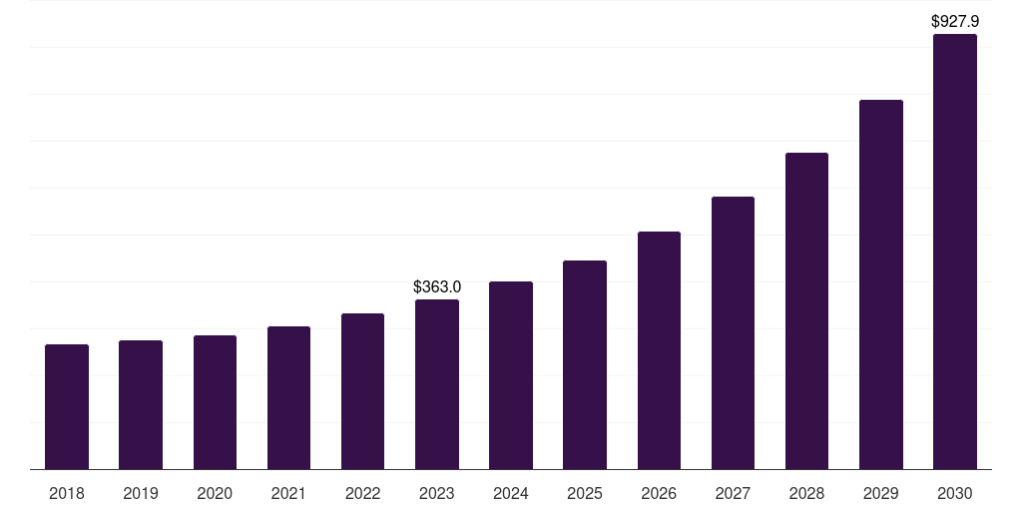
Fig: UK e-commerce market, 2018 to 2030
(Source: Grand View Research, Inc., 2024)
Amazon UK operates in the highly developed e-commerce system in the UK which is among the top three worldwide. According to the Office for National Statistics Digital Economy Survey, online sales of websites in the UK amounted to about PS459.2 billion in 2021 and it rose 28.8 percent compared to 2019 (Office for National Statistics., 2023). The UK e-commerce market is expected to keep expanding at the double digit rates, according to one of the industry estimates, the UK market will have reached US $927 billion in 2023 (Grand View Research, Inc., 2024).
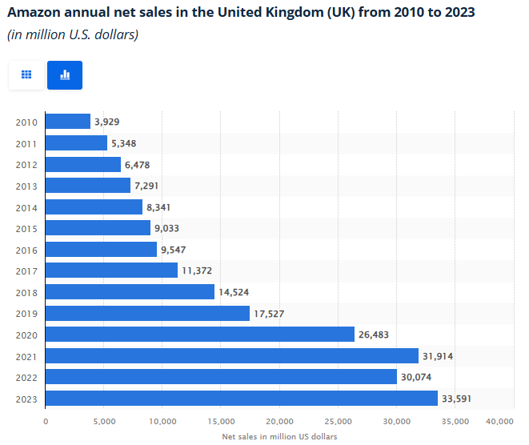
Fig: Amazon annual net sales in the UK from 2010 to 2023
(Source: Statista. 2024)
In this market, Amazon UK takes a dominant position. Data available in the industry indicates that in 2023 Amazon UK net sales were US33.59 billion and it has more than 30% market share in UK e-commerce (Statista. 2024). The UK itself indicates that the country is the third largest of the international revenues of Amazon (Amazon UK Services Ltd. 2023).
The UK business model of the firm is multi-faceted. It has direct retailing of goods, large third party marketplace platform, subscription revenues through Amazon prime, and rapidly expanding digital advertisement and cloud services. Debatably, the UK tax and investment report of Amazon UK describes that in 2023, Amazon invested over 12 billion euro in the UK, it has over 75,000 permanent employees and has paid over 4.3 billion euro in taxes (Amazon UK Services Ltd. 2023).
The Amazon UK range of products includes electronics, fashion, groceries (through Amazon Fresh), digital media and devices that are smart. Its services are Prime membership, Kindle, and Aws cloud hosting to enterprises and government customers. Such a mix of physical goods and online services promotes a hybrid B2C and B2B2C system that uses the economies of scale and sophisticated analytics. The brand image of Amazon UK focuses on comfort and innovativeness, which has always been one of the most trusted online brands in the UK (YouGov, 2023). Its sustainability projects like zero-emission deliveries and recyclable packaging also support its image as a market leader who is responsible.
The value proposition will be based on customer convenience (fast delivery, big assortment), dynamic pricing, and data driven personalization engine that enhances retention and cross sell. Brand wise, Amazon claims to be the most customer focus firm on the earth, innovative, logistical and digital experience. On the basis of data-driven foundations, the marketing structure, CRM architecture, and analytics possibilities of Amazon UK fit well within its overall business model, providing the competitive advantage in the UK market.

Marketing Department Structure & Architecture
Overview
The marketing department that Amazon UK is engaged in is a data driven customer oriented ecosystem that engages both its technological infrastructure as well as its logistics infrastructure. The mission of the firm as the most customer focus organisation on Earth is operationalised through a marketing framework that incorporates analytics, automation and brand innovation. According to Amazon UK Services Ltd. (), the company spent more than 12 billion euro on its operations in the UK, where big amounts of money were spent on data analytics, CRM integration, and ads systems. Its management borrows the matrix structure, which allows the collaboration of data scientists, brand strategies and operations managers of Amazon.co.uk, Alexa, and Amazon Fresh platforms at the same time.
Organisational Structure
The CMO or Chief Marketing Officer of the company is the one in charge of strategic marketing analytics governance, and international alignment with the headquarters of Amazon. It has five specialised divisions that make up the department and each division has a part to play in the digital marketing structure of the firm.
- Digital Marketing and Acquisition Division: Oversight of paid advertising via Amazon Advertising Console, Google Ads and Meta Business Suite. Amazon UK also dominates in performance marketing by the amount of its digital ad revenue exceeding PS1.4 billion in 2024 (Statista, 2024).
- CRM and Customer Analytics Division: Consolidates both AWS Data Lake and Salesforce Marketing Cloud to handle more than 50 million customer profiles in UK. With machine learning and collaborative filtering, the division customises customer journeys and predicts growths in retention (Shen et al., 2023).
- Brand Strategy and Creative Division: comes up with consistent campaigns, such as Prime Day and Black Friday UK, which yielded more than PS2.08 billion in sales in the UK (Taylor, 2025).
- Performance Analytics and Data Science Division: AWS QuickSight and Tableau are used to track KPIs, including Customer Lifetime Value and Return on Marketing Investment.
- Customer Experience and Retention Division: Measures post-purchase satisfaction and loyalty, the NPS score is above 70.
Marketing Architecture
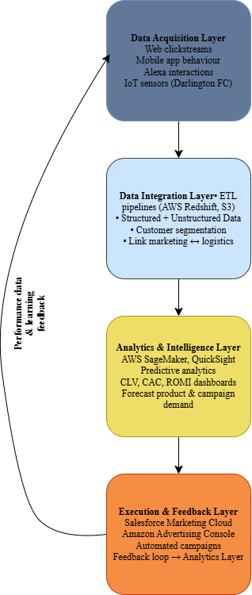
Fig: Amazon UK Marketing Architecture – Four-Layer Data Model
The marketing activities of Amazon UK are supported by a four-tier digital architecture in accordance with its supply chain and data ecosystem (Maddock-James, 2025):
Data Acquisition Layer: Collected multi-channel inputs consisting of web clickstreams, Alexa interactions and fulfilment internet of things sensors to monitor delivery and stock.
Data Integration Layer: Unites structured and unstructured data with ETL pipelines in AWS Redshift and S3, linking marketing information and logistics potential.
Analytics and Intelligence Layer: Scale dwells on the AWS SageMaker and QuickSight to anticipate campaign conversion, CustomerLifetimeValue, and product demand, in which marketing judgments are connected to the fulfilment talents of Darlington and other centres in the UK.
Execution and Feedback Layer: Implements insights using Salesforce Marketing Cloud and Amazon Advertising Console, which optimise the targeting, timing, and product recommendations in real time.
This structure establishes a feedback mechanism that keeps marketing, CRM, and operations in a continuous loop, such that the campaigns are not only data-driven but also supply-driven, which is a trait of marketing brilliance at Amazon on a global scale.

CRM System Design
Overview
The Customer Relationship Management system of Amazon UK is a unique, state-of-the-art proprietary framework, which was created to achieve hyper-personalisation, lightning-fast service, and data-driven contact with millions of customers. Amazon has built its own CRM ecosystem in-house, and this is integrated with Amazon Web Services, the cloud-computing infrastructure, unlike most companies, which only use third-party CRM platforms including Salesforce or HubSpot (Cox, 2024).
This custom-built architecture will enable Amazon to bring together the behavioural, transactional, and sentiment data of its key customer touchpoints (Amazon.co.uk, Alexa, Prime Video, Amazon Fresh, and Amazon Music) into a single real-time data environment. In 2023, the Amazon UK Services Ltd. also disclosed a figure of over 50 million active users in the UK which was assisted by extensive investment in CRM, data analytics, and advertising infrastructure. The aim of the system is to transform this large data quantity into insight that can be acted upon to increase customer lifetime value, retention and satisfaction.
Core CRM features and Architecture
The CRM system used by Amazon has three layers, which are connected to each other and incorporate Amazon-created data infrastructure and AWS technologies:
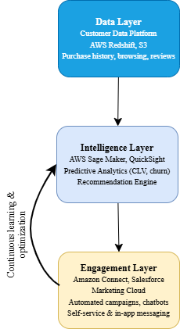
Fig: Amazon UK CRM System Architecture
- Data Layer (Customer Data Platform): Data layer is centralised on AWS Redshift and S3 and is consolidated purchase history, browsing data, voice commands and product reviews. The infrastructure supports the recommendation engine that is industry-leading and the dynamic pricing features of Amazon (Cox, 2024; Amazon Web Services, 2024).
- Intelligence Layer (AI & Predictive Analytics): The intelligence layer uses AWS SageMaker on machine-learning models to predict purchasing intent, churn risk, and next-best-offer opportunities. The sentiment analysis based on NLP extracts information contained in chat logs and reviews, which are constantly being analyzed in QuickSight dashboards to pass the information to the marketing teams (Maddock-James, 2025).
- Engagement Layer (Automation & Customer Experience): The engagement layer is the provision of omni-channel communication, using Amazon connect, Salesforce marketing cloud, and automated email or in-app messaging. Self-service order tracking, AI-based chat, and instant refund processing are some examples of the way Amazon focuses on speed and convenience: both of which are driving forces of its position as the top three bargaining brands globally in 2025 (Cox, 2024).
Integration and Feedback Loop
The CRM ecosystem of Amazon is directly connected to the fulfilment network and inventory, which allows it to view its stock in real-time and predicts the need to restock its stocks in the UK locations like Darlington. Customer interaction data is fed back into the layer of analytics, and algorithms are trained on new trends, resulting in a cycle of continuous improvement. This feedback mechanism enables Amazon to become almost perfectly responsive to customers, and harmonize marketing, logistic and service performance, a feature of CRM engineering excellence in the world.

Marketing Strategies / Campaign Ideas
The marketing strategy of Amazon UK operates on the basis of its integrated data and customer relationship management architecture that provides hyper-personalised and customer-centric campaigns to the maximum level of engagement and retention. The key element of this strategy is the application of predictive analytics using AWS SageMaker and Salesforce Marketing Cloud to forecast customer demand and do real-time targeting.
One of the most significant ones is a new venture titled Prime Moments UK, based on the success of the previous Prime Day that Amazon held in 2024 and achieved a PS633 million a single-day purchase-up sale, an increase of 9.1 percent as compared to 2023 (Retail Gazette, 2024). This campaign uses behavioural segmentation to detect key life moments, including relocation, parenthood, or university transitions, based on the wish-list and purchase-pattern data to provide the timely personalised offers.
The other flagship program, the Sustain with Amazon, is the marketing of eco-friendly products and approved partners through the Climate Pledge Friendly marketplace. According to the 2024 Sustainability Report, Amazon boasts over 1.4 million certified sustainable goods available worldwide, and with the growing need of the UK consumers toward ethical purchasing, the company is able to respond (Amazon UK Press Centre, 2024). Besides, Amazon UK also employs the A/B testing, social integration with Tick Tok Shop and Instagram Reels, and voice-based promotions via Alexa to become more visible in the omnichannel. Such information-driven plans are the development of Amazon UK as the transactional to predictive relationship marketing.

KPIs and Data Points
Category | KPI / Data Point | Definition & Formula | Decision-Making Relevance
Customer Acquisition | Customer Acquisition Cost (CAC) | Measures cost to acquire one new customer. Formula:  Total Marketing Spend / New Customers Acquired | Helps Amazon evaluate campaign efficiency and adjust ad budgets across channels (Search, DSP, and Social) (Focus Digital., 2025).
Customer Engagement | Advertising Awareness Uplift | Tracks change in brand awareness after major campaigns.  Formula:  Post-Campaign Awareness % – Pre-Campaign Awareness % | Quantifies the impact of advertising campaigns such as Prime Day or Black Friday on customer recall and engagement (YouGov., 2025).
Customer Conversion | Conversion Rate (CR) | Measures efficiency of converting website visitors into buyers. Formula:  (Purchases ÷ Website Visits) × 100 | Indicates funnel performance and UX effectiveness; supports optimization of landing pages and checkout flow (Amazon Advertising., 2024).
Customer Retention | Prime Membership Penetration | Percentage of total UK shoppers subscribed to Amazon Prime.  Formula:  (Prime Members ÷ Total Shoppers) × 100 | Assesses retention strength and loyalty value, influencing subscription strategy and delivery incentives (YouGov., 2024).
Brand Loyalty & Satisfaction | Net Promoter Score (NPS) | Measures customer satisfaction and likelihood to recommend.  Formula:  % Promoters – % Detractors | Evaluates customer advocacy and service quality, informing CX and fulfilment improvements (Marketing Week., 2025).
Advertising Reach | Prime Video Ad Tier Reach | Monthly audience reach for Amazon’s ad-supported video tier. | Guides cross-channel targeting and supports integrated ad planning between entertainment and e-commerce ecosystems (Marketing Week., 2025).
Revenue Efficiency | Return on Marketing Investment (ROMI) | Measures profitability of marketing spend.  Formula:  (Revenue from Campaign – Cost) ÷ Cost | Identifies high-ROI campaigns for scaling; informs budget reallocation and optimization (Amazon Advertising. 2024).
Customer Lifetime Value (CLV) | CLV Measurement via AMC | Predicts long-term customer revenue potential.  Formula:  Avg. Order Value * Purchase Frequency * Customer Lifespan | Enables predictive segmentation and investment in high-value cohorts using longitudinal data (Amazon Advertising. 2024).
Table: Key Marketing KPIs and Data Points for Amazon UK

Data & Analytics Framework
The data and analytics platform at Amazon UK combines the multichannel customer data with predictive analytics to improve the precision of marketing and customer experience. With the help of AWS Redshift and S3, Amazon.co.uk, Alexa, and Prime Video data are united in one central data lake and analyzed in real-time. AWS SageMaker operates machine learning models to make predictions on churn, customer segmentation, and optimization of recommendations, which facilitate dynamic personalization of channels (Amazon Web Services, 2024). Data is visualized in AWS QuickSight, which enables the marketing department to monitor such KPIs as CLV, CAC, and ROMI. Predictive algorithms are very much related to the AI-based recommender systems that enhance cross-selling and customer retention (Zhang et al., 2021). Moreover, the budget allocation optimisation models constructed with the help of data-driven methods will guarantee efficient spending on marketing and higher ROI (Wang et al., 2020). This unified analytics infrastructure will make Amazon UK make informed, adaptive, and scalable marketing decisions with support of continuous feedback loops.

Optimization Model (Excel Solver LP)
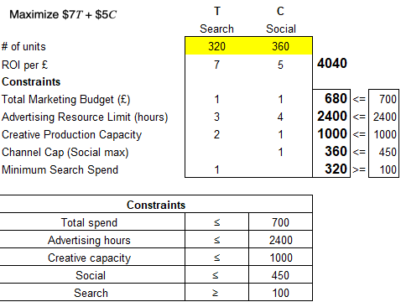

This optimisation of the linear programming is directly consistent with the data-driven marketing strategy of Amazon UK, which aims to maximize the ROI in various digital channels based on advanced analytics and automation. The model reflects the way Amazon uses its marketing budget on Search advertising (such as sponsored product ads) and Social media campaigns (such as targeted Meta or TikTok ads) to maximize the level of return on investment within certain limits of operational and budgetary constraints.
The objective function, (7T + 5C) is the goal of maximizing marketing performance by focusing on the most efficient channels such as Search that in the past had a better conversion rate because of intent-based targeting. The constraints namely PS700 overall marketing budget, 2,400-hour limit resources on advertising, and 1000-hour limit resources on creative production are real-life operational considerations at Amazon such as staffing capacity and planning its resources in creative production. The social channel constraint and minimum search cost is a simulation of the requirements of Amazon to strike a balance between long term brand awareness (through social platforms) and short term sales performance (through search advertising).
The ideal balance of resource use and marketing effect is that of 320 Search units and 360 Social working to generate 0.04040 PS4,040 ROI. This is indicative of the application of predictive analytics and machine learning systems such as AWS SageMaker that Amazon UK has implemented to constantly review the performance of campaigns and dynamically redistribute resources according to current performance. These optimization models have helped Amazon to guarantee that every pound of its marketing expenditure generates a quantifiable value, which complies with its strategic goal of performance-based and customer-centric marketing that will support its growth and operational efficiency in a competitive online marketplace.

Conclusion
To sum up, this project identifies that the data-driven marketing and CRM architecture of Amazon UK can contribute to operational efficiency, personalization, and profitability. Through the combination of analytics, AI and optimization modeling, Amazon is able to efficiently distribute marketing resources in order to generate the highest ROI and yet be customer-centric. The balanced scorecard of the performance between the short-term and long-term brand engagement in the form of strategic budget allocation is shown by the linear programming model. It is an analytical ecosystem, which is enabled by AWS infrastructure and provides real-time data feedback, which enables Amazon UK to take evidence-based decisions, optimize their campaigns and maintain a competitive edge in the fast-changing UK e-commerce market through innovation and identifiable marketing excellence.

References
Amazon Advertising. (2024). Amazon Marketing Cloud measurement expansion. Retrieved from https://advertising.amazon.com/en-gb/library/news/amc-measurement-expansion
Amazon UK Services Ltd. (2023). Amazon UK tax and investment report 2023. https://assets.aboutamazon.com/4e/02/c54ea5454bb09b3cc6d467fd62c3/uk-tax-report-2023-final-4.pdf
Amazon Web Services. (2024, May 15). Learn how Amazon Ads created a generative AI-powered image generation capability using Amazon SageMaker [Blog post]. https://aws.amazon.com/blogs/machine-learning/learn-how-amazon-ads-created-a-generative-ai-powered-image-generation-capability-using-amazon-sagemaker/
Focus Digital. (2025). Customer acquisition cost on Amazon: 2025 benchmark analysis. Retrieved from https://focus-digital.co/customer-acquisition-cost-amazon/
Grand View Research, Inc. (2024). UK e-commerce market size & outlook, 2023-2030. https://www.grandviewresearch.com/horizon/outlook/e-commerce-market/uk
Maddock-James, J. (2025). Supply-chain infrastructure as architecture: a case study of Amazon in Darlington, UK. Mobilities, 1-16.
Marketing Week. (2025). Amazon Prime Video ad-supported tier launches in the UK. Retrieved from https://www.marketingweek.com/amazon-prime-video-ad-tier/
Marketing Week. (2025). Brands that excel at customer experience according to NPS. Retrieved from https://www.marketingweek.com/brands-excel-customer-experience-nps/
Office for National Statistics. (2023, April 20). Digital Economy Survey: 2021 – Use of information and communication technology (ICT) and the value of website sales by UK businesses. https://www.ons.gov.uk/businessindustryandtrade/itandinternetindustry/bulletins/digitaleconomysurvey/2021
Statista. (2024). Net sales of Amazon in the United Kingdom (UK) from 2017 to 2024 [Data set]. Statista. https://www.statista.com/statistics/1035592/net-sales-amazon-united-kingdom-uk/
Taylor, N. (2025, July 14). UK sales for Amazon Prime’s first four-day event outperform Black Friday. FashionNetwork. https://uk.fashionnetwork.com/news/Uk-sales-for-amazon-prime-s-first-four-day-event-outperform-black-friday%2C1749074.html
Wang, X., Li, F., & Jia, F. (2020). Optimal advertising budget allocation across markets with different goals and various constraints. Complexity, 2020(1), 6162056.
YouGov. (2024). Online retailers could do well to analyse Amazon’s customer base. Retrieved from https://yougov.com/articles/22895-online-retailers-could-do-well-analyse-amazons-cus
YouGov. (2025). UK advertisers of the month: Amazon, McDonald’s and Lynx. Retrieved from https://yougov.com/en-gb/articles/52793-july-uk-advertisers-of-the-month-amazon-mcdonalds-and-lynx
Zhang, Q., Lu, J., & Jin, Y. (2021). Artificial intelligence in recommender systems. Complex & intelligent systems, 7(1), 439-457.

